September 28, 2017
Dear Friends,
Embracing and Growing in God’s Love is this year’s stewardship theme, reminding us of God’s life-giving and limitless love, and how we are called to respond to that love. As 1 John says, “We know love by this that he laid down his life for us—and we ought to lay down our lives for one another. How does God’s love abide in anyone who has the world’s goods and sees a brother or sister in need and yet refuses help? Little children, let us love, not in word or speech, but in truth and action” (1 John 3:16-18). God shows us his love through his actions in the world, not only through Jesus’ self-sacrifice on the cross 2,000 years ago, but also through his ongoing providential care for each of us today. Here at St. Timothy’s, we embrace and grow in that love through concrete actions that demonstrate our love for God and each other at St. Timothy’s, and for our neighbors in Herndon and throughout the world.
Over the next month we will be sharing with you stories of how St. Timothy’s is a unique place in this world—a place that does indeed see brothers and sisters in need, and offers help. These stories are not limited to those who attend church here on Saturday or Sunday. Our church embraces and touches people who often feel forgotten, people who participate in the more than 20 ministries that meet in our building, and people in our local community with no formal affiliation to St. Timothy’s. These stories demonstrate how our love is changing lives by empowering, uplifting, befriending, and restoring hope. These stories, which will appear in the Sunday bulletin and weekly e-news, show how we serve, feed, worship, share, and teach—how we fulfill our mission.
This November, we will celebrate 149 years of service in God’s name, thanks to generations of members who have embraced and grown in God’s love by offering generous gifts of their time, talent, and treasure. Now it’s up to us.
Enclosed is your 2018 pledge card. Between now and Celebration Sunday on November 5th, prayerfully consider how God is calling you to support this place. Some members give proportionally, committing a certain percentage of their income, while others give as they are able. On the back of this letter are proportional giving charts for weekly or monthly giving. We hope that you will use these charts to find where you are now in your proportional giving, and prayerfully consider increasing to the next percent. Every gift and pledge is gratefully received, and we ask you return your completed pledge cards in the offering plate or by mail by Sunday, November 5th.
Your financial gift funds the people and the facilities that make this incredible place possible—a place that embraces all people and enables us all to grow in God’s love. Thank you for embracing and growing in God’s love here at St. Timothy’s!
Faithfully yours,

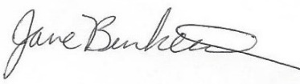
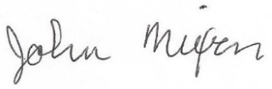
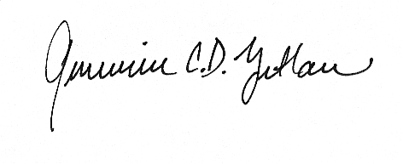

The Rev’d Rich Bardusch Jane Burkett and John Nixon Genevieve Zetlan
Rector Stewardship Chairs Senior Warden

